Reasoning
Claim
 | Why does the evidence support the claim? | Why does the evidence support the claim? | Why does the evidence support the claim?
 | What is the underlying science concept? | What is the underlying science concept? | What is the underlying science concept?
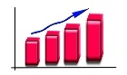  Evidence | Evidence: | Evidence: | Evidence:

