Winter Is Coming! Are You Adapted?
A Next Generation-linked Study in Ecological Genetics of Plant Adaptation
Lesson by Marty Buehler and Torrey Wenger

Overview
NGSS are about the art of teaching rather than just content expectations. In this lesson, we will teach an ecology lesson about adaptation to environmental challenges.
With accelerating changes to our natural environments, it has become increasingly important to understand the factors that affect the potential for adaptive responses. A current challenge receiving much attention is climate change.
Students will design a protocol and compare their findings with already existing data recently discovered by actual scientists.
Objectives
At the conclusion of the lesson, students will be able to:
- Define ecosystem, adaptation, trade-offs, fitness, (additional items as needed)
- Design and carry out standardized protocols to conduct an experiment
- Grow from seed and learn about the life cycle and characteristics of Arabidopsis thaliana (the first plant to have its full genetic makeup sequenced and catalogued)
- Investigate the genetic mechanisms of adaptation
- Graph data and interpret results, compare and contrast data
Length of Lesson
This lesson uses 2-3, 50-minute periods to develop the protocol through student discussion and to set up the experiment, and 1-2, 50-minute periods to analyze and report the results. In between these periods of time, students are growing their own plants and doing small tasks everyday (a few minutes) such as watering and making observations. From planting the seeds to running the experiment takes about 25 days, yet most of the time is waiting for plants to grow.
Grade Levels
This activity is best suited for a standard biology classroom. If higher level genetics are included, such as a discussion of genetic mapping approaches, it could be easily adapted for AP Biology and advanced classes. It can be variable in grade level as it can easily be adjusted for middle school or lower levels by providing the experimental protocol, or simplifying concepts to address.
Standards Covered (NGSS)
Performance Expectations:
Middle School
- MS-LS1-4: Use argument based on empirical evidence and scientific reasoning to support an explanation for how characteristic animal behaviors and specialized plant structures affect the probability of successful reproduction of animals and plants respectively
- MS-LS1-5: Construct a scientific explanation based on evidence for how environmental and genetic factors influence the growth of organisms.
- MS-LS3-1: Develop and use a model to describe why structural changes to genes (mutations) located on chromosomes may affect proteins and may result in harmful, beneficial, or neutral effects to the structure and function of the organism.
- MS-LS4-4: Construct an explanation based on evidence that describes how genetic variation for traits in a population increases some individuals’ probability of surviving and reproducing in a specific environment.
- MS-ETS1-4: Develop a model to generate data for iterative testing and modification of a proposed object, tool, or process such that an optimal design can be achieved.
High School
- HS-LS4-2: Construct an explanation based on evidence that the process of evolution primarily results from four factors: (1) the potential for a species to increase in number, (2) heritable genetic variation within a populations due to mutation and sexual reproduction, (3) competition for limited resources, and (4) the proliferation of those organisms that are better able to survive and reproduce in the environment given their genetic differences.
- HS-LS4-3: Apply concepts of statistics and probability to support explanations that organisms with an advantageous heritable trait tend to increase in proportion to organisms lacking this trait.
- HS-LS4-4: Construct an explanation based on evidence for how natural selection leads to adaptation of populations.
- HS-LS4-5: Evaluate the evidence supporting claims that changes in environmental conditions may result in: (1) increases in the number of individuals of some species, (2) the emergence of new species over time, and (3) the extinction of other species.
Cross Cutting Concepts:
- Patterns
- Cause and effect
- Scale, proportion, and quantity
- Systems and system models
- Structure and function
- Stability and change of systems
Science and Engineering Practices
- Asking questions (for science) and defining problems (for engineering)
- Developing and using models
- Planning and carrying out investigations
- Analyzing and interpreting data
- Using mathematics and computational thinking
- Constructing explanations (for science) and designing solutions (for engineering)
- Engaging in argument from evidence
- Obtaining, evaluating, and communicating information
Materials
- Background PowerPoint available (with optional follow-up questions)*
- Excel file of existing data from the Schemske lab available*
- Arabidopsis thaliana seeds – 2 strains, SPE-7 (from Spain, latitude = 42) and INNF-10 (from Norway, latitude = 63)**
- Small pots with potting mixture**
- Tray to hold pots**
- Appropriate lights, with a way to support them (pvc rack)**
- Timer for the lights**
- Sharpie-type marker to label the pots with (underneath)
- “Plant tags” to number the pots with (sticking up in soil)
- Refrigerator (with room for lights) and freezer – tray must fit!
- Spray bottle and small watering bottle
- Sharp pointy tweezers
- Hand magnifier or dissecting scope
- Foil to cover the pots (if necessary)
*These materials can be found on the KBS K-12 Partnership website, search for “lesson plan”: http://www.kbs.msu.edu/outreach/kbs-k-12-partnership/
**These materials can be requested as needed (a whole kit or just the seeds) from the Doug Schemske lab. Please contact the KBS K-12 Partnership coordinator.
Background
Arabidopsis thaliana (hereafter "Arabidopsis") , or Mouse-ear Cress, is commonly used for genetics experiments for several reasons. First, like the fruit fly, it has a small number of chromosomes, making it a “simple” system – Arabidopsis has 5 pairs of chromosomes (a fruit fly has 4 and a human has 23). Second, it’s a small annual plant that’s relatively easy to grow in a lab, so results can be seen quickly (from germination to setting seed can be as little as 6 weeks). Third, it readily self-pollinates and produces plenty of seeds, making it possible to create homozygous lines (that is, each chromosome in the pair has the same information) simply through plant breeding techniques. Fourth, its entire genome has been sequenced and information on the function of many of the genes is available.
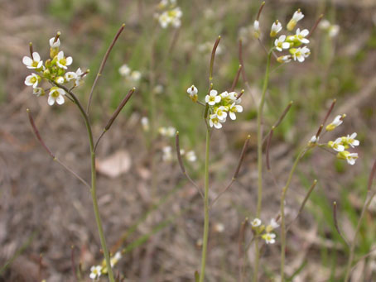
Figure 1: Arabidopsis flowers and fruits (Photo courtesy of Schemske lab)
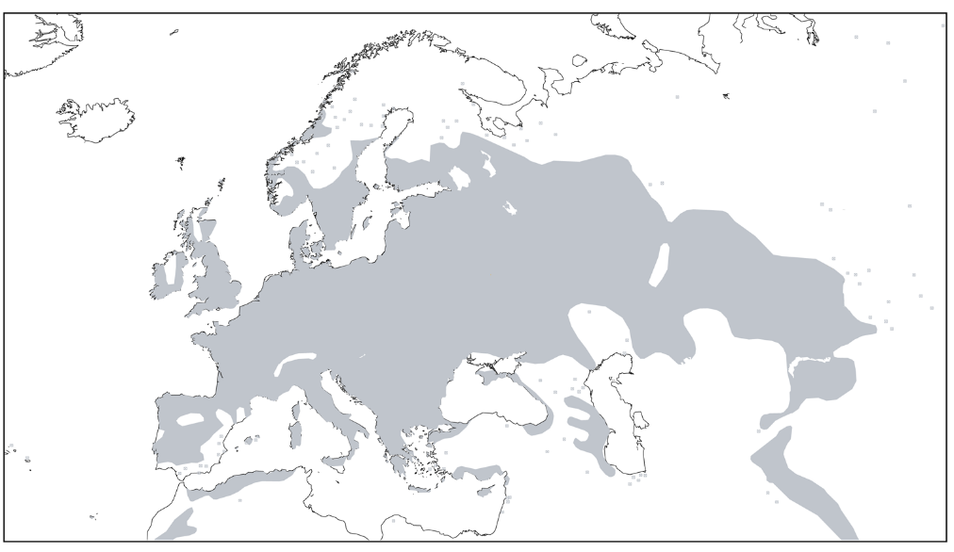
Figure 2: Native range of Arabidopsis (Map courtesy of James Beck)
A member of the mustard family, Arabidopsis is native to Eurasia but naturalized populations exist on all continents except Antarctica. In the contiguous United States, populations have been documented in all but 6 states. It is a pioneer species, readily colonizing rocky or sandy soil before being pushed out by larger competitors. The seeds typically germinate in the fall, the plant overwinters as a rosette, and small white flowers are produced on stalks up to 10 inches tall in the spring. Arabidopsis self-pollinates > 95% of the time and a single plant can produce thousands of seeds.
Currently the Schemske lab at Michigan State University and their collaborators are investigating adaptations for freeze tolerance, disease resistance, flowering time, photosynthesis, and circadian rhythm. They are particularly interested in fitness trade-offs; for example, producing “antifreeze” to survive a cold winter might have a negative effect on the number of seeds produced in warmer environments. In the freeze tolerance studies, parent strains were chosen from the northern and southern ends of the plant’s range: Sweden and Italy. Starting from Swedish-Italian hybrids, hundreds of recombinant inbred lines (RILs) were created through careful plant breeding; each line is homozygous for every gene but is different from the other lines. Multiple replicates of both the parent strains and hundreds of RILs were planted at both parent locations and their survival and fruit production (a stand-in for overall fitness) were recorded. (Since Arabidopsis seeds are the size of finely ground pepper, it would be challenging to count them accurately.)
Not surprisingly, each parent strain fared best in its native location. The Swedish strain struggled in Italy while the Italian strain struggled during normal Swedish winters but did OK during a mild winter. As expected, the RILs were more variable in their survival and seed production. After the field trials, the genetics of each RIL was examined. Unique genetic markers were used as arbitrary “section breaks”: If the marker came from the Swedish parent, the whole section was assumed to be from the Swedish parent. These markers were used to map Quantitative Trait Loci (QTL), sections of the chromosome that are responsible for variation in the traits in question, winter survival and fruit production. A total of 15 locations were identified for fitness; one-third of these QTL showed evidence of trade-offs. For example, a DNA region might be associated with higher survival but also with lower fruit production, depending on the environment the plant was grown in.
The next step in this research is to investigate other traits for potential trade-offs and to determine which genes in particular are in the identified QTL. This knowledge could be applied to food crops, horticulture, or even animal breeding.
The classroom experiment is a modification of the freezing tolerance assay conducted in the Schemske lab. In the lab, seed from 500 Sweden/Italy RILs were germinated in petri dishes and grown in growth chambers with carefully controlled conditions; after the seedlings were established but while they were still small, conditions in the growth chamber were changed to mimic a cooling period and then a week-long freezing period. In the classroom, only 2 strains will be used, from Norway and lowland Spain. (Out of the 63 populations surveyed, these 2 yielded the best results in the classroom-style experiment.) Seedlings will be grown in peat in small pots, under lights in a classroom. The cool-down period (with lights) will take place in a refrigerator and the 2-hour freezing period will take place in a freezer.
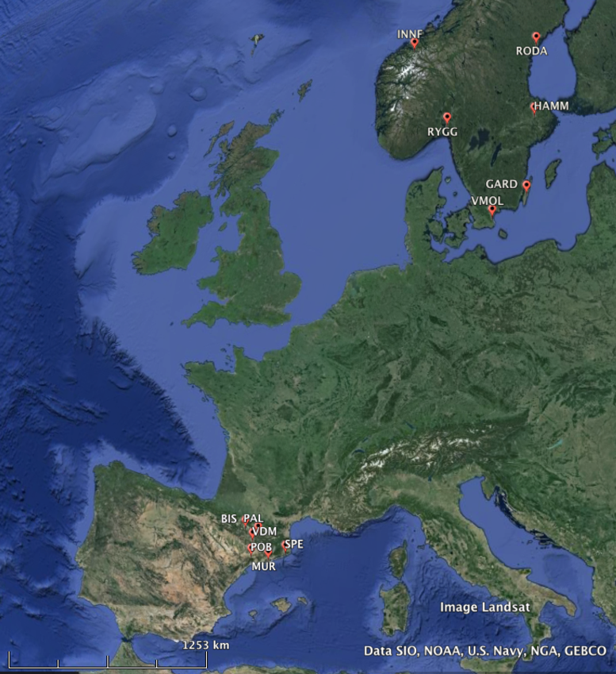
Figure 3: Map of Arabidopsis populations in this experiment. (Map courtesy of Schemske lab.)

Activities of the Lesson
Class 1: Introduce project with PowerPoint presentation to generate discussion of adaptation, genetic variability, trade-offs, and climate zones. Discuss how to measure adaptation and fitness (study design) using a common lab plant species, Arabidopsis. Generate science questions and guide discussion to design experiment together.
Class 2: Prepare pots and potting medium, plant seeds. Label the pots with a number and the strain type (e.g., SPE-7 or INNF-10). The tray containing the pots will then go into the refrigerator for cold stratification. Note: Are there visible differences between the seeds of the different strains? Also, as you practice student centered design, look for opportunities to encourage students to do side experiments. In this case, maybe if they question cold stratification, ask them if there is a way to test if it is necessary for germination. A simple second set of seeds could be planted without cold to compare effect., and why it might be adaptive.
Class 3 (partial): Thin the seedlings down to 10 plants per pot. (Any number will work but 10 will aid in calculation of survival percentages.) This needs to happen before the plants go into the refrigerator for cold acclimation prior to freezing. Arabidopsis does not tolerate competition so aim for well-spaced plants. Try to avoid jostling the plants too much, as that activates some genes and may affect the experimental results. Note: Are there visible differences between the seedlings? (Don’t look at the labels!) Recording observations is a good skill to develop.
Class 4: Score survival. Create graphs of the data and write the lab report. Compare results between strains and between class periods. Students may want to examine plants again on subsequent days to make sure that “dead” plants are really dead.
Class 5: Wrap-up discussion: What was surprising? Did the results match predictions? Why is this useful to learn? Note: Doug Schemske and his research partner Christopher Oakley would like a report of results and suggestions to improve the experiment. This could be a class-wide discussion or a teacher-only report. You may then relay the message or maybe have a student report the results and suggestions through email directly to Dr. Oakley or Dr. Schemske. You may also contact the KBS K-12 Partnership coordinator.
Dr. Oakley can be contacted at: coakley@msu.edu
Dr. Schemske can be contacted at schem@msu.edu
Timeline
Day 0: Introductory PowerPoint and study/discuss design
Day 1: Plant seeds, begin cold stratification (control-side experiment?)
Day 6: End stratification, plants go under lights on bench top, water gently with distilled each day.
Day 10: Take lids (or plastic wrap) off pots
Day ~20: Thin plants, if necessary.
Day 22: Plants acclimate in the refrigerator, with lights. (This day may vary, depending on plant growth. You will know if it is time to go into refrigerator when SPE-7 has at least 4 true leaves and INNF-10 has at least 6.
Day 24: Freeze for 2 hours, then return to standard bench top conditions. (This may vary; freezing happens after 2 days of acclimation.)
Day 27: Score survival. (This may vary; scoring happens 3 days after freezing.)
Assessment options:
Communication (written formal report or group report or some portion of such)
Have students write about student generated questions (see below).
Mathematics and graphing (require data tables, averages, graphs, etc)
One possible example:

Possible Questions to Generate with Students
Which strain do you predict will survive the cold better, and why?
Why would freezing tolerance be more important in one part of the plant’s range than another?
Would plants from the mountains in Spain be more similar to plants from the Spanish lowlands or to plants from Norway?
Do you think different genes are favored in these 2 regions, and why?
Did the results match your prediction? How could we improve this experiment?
Have you seen these plants in the wild?
What advantage do these plants gain by overwintering as rosettes, and is it worth it?
If being freezing tolerant means the plant produces fewer seeds in warmer years, is it worth it?
What does the term trade-off mean? What other trade-offs do you think these plants might make?
Do plants where you live have to make similar trade-offs?
How does climate change affect plants?
Can the plants adapt to climate change?
How could developing freezing tolerant plants be useful in agriculture? Will freezing tolerance always increase yield?
What is the broader geographic distribution of freezing tolerance?

Protocol
- Place peat discs in 2 oz plastic cups. Cover with water, allow soil to fully expand. Pour off excess water. Take mesh wrapping off the soil, and flatten soil (loosely) into cups.
- Label pots with intended plant line and unique pot number (randomized). If you have 32 total pots in a tray, label the pots 1 through 32.
- Sprinkle ~20 seeds of intended plant line on the soil surface of each pot.
- Gently spray pots with water, then cover with lids or plastic wrap (spray lids with water as well).
- Put the tray of pots in the refrigerator at ~4°C with no light for 5 days (cold stratification) to induce germination. If the refrigerator will be opened frequently during this period, place the pots in a light proof box or cover with foil.
- After 5 days, take tray of pots out of the refrigerator and put under a bench top light at room temperature. Set the lights to a 16-hour day/ 8-hour night cycle. Keep the lids on for 4 more days. Water only if soil starts to look dry.
- Take lids off after 4 days of bench top growth. Top water all pots.
- Grow plants on the bench top for 16 days. Water as needed.
- After germination, thin to desired number of plants (10 plants makes for easy analysis).
- 3 weeks after sowing seeds, the plants should be large enough to put into the acclimation phase. At this stage, all plants should have 4-6 true leaves. (Cotyledons, the first two leaves that emerged, don’t count.) Record number of plants in each pot.
- Place the tray of pots under a light stand in the refrigerator at ~4°C for 2 days. Set the lights to an 8-hour day/ 16-hour night cycle.
- After two days, place plants into freezer with no lights for 2 hours.
- Take tray out of the freezer after 2 hours and place back under bench top lights (room temperature, 16-hour day/ 8-hour night). Keep here for 3 days.
- After three days, record survival. Only count the plants that survived.
Extensions and Modifications
Data Nuggets are being developed to go with this activity. Please check the website: http://datanuggets.org/
For middle school students, the protocol could be provided first rather than developed by the students.
For advanced biology students, this activity could lead into DNA extraction, growing and testing the next generation, and discussion of SNPs (single nucleotide polymorphism, the “markers” discussed in the background section) and Qtl (quantitative trait locus).
Arabidopsis plants can also be grown concurrently for use with Mendelian experiments (trichome traits, for example) or for other plant based experiments. About 3-4 generations can be grown from seed to fruit and repeated in one school year. Additional strains are available from the Schemske lab or can be purchased from scientific retailers. All levels of students benefit from growing plants! One source of ideas should be checked out at: http://arabidopsis.osu.edu/static/docs/CS19994%20Teacher%20Guide.pdf
Resources
Ågren, J, CG Oakley, JK McKay, JT Lovell, and DW Schemske. 2013. Genetic mapping of adaptation reveals fitness tradeoffs in Arabidopsis thaliana. Proceedings of the National Academy of Science 110: 52, 21077-21082. http://www.pnas.org/cgi/doi/10.1073/pnas.1316773110
Ågren, J, and DW Schemske.002012. Reciprocal transplants demonstrate strong adaptive differentiation of the model organism Arabidopsis thaliana in its native range. New Phytologist 194: 1112-1122. http:doi.org/10.1111/j.1469-8137.2012.04112.x
Krämer, U. 2015. Planting molecular functions in an ecological context with Arabidopsis thaliana. eLife 4: e06100. http://doi.org/10.7554/eLife.06100
Oakley, CG, J Ågren, RA Atchison, and DW Schemske. 2014. QTL mapping of freezing tolerance: links to fitness and adaptive trade-offs. Molecular Ecology 23: 4304-4315. http://doi.org/10.1111/mec.12862
TAIR (The Arabidopsis Information Resource). 2016. About Arabidopsis. https://www.arabidopsis.org/portals/education/aboutarabidopsis.jsp#world Accessed: 7 July 2016.
The Arabadopsis Genome Initiative. 2000. Analysis of the genome sequence of the flowering plant Arabidopsis thaliana. Nature 408: 796-815.
USDA – Natural Resources Conservation Service. 2016. Plants Database: Arabidopsis thaliana. http://plants.usda.gov/core/profile?symbol=ARTH Accessed: 7 July 2016.
Wikipedia. 2016. Arabidopsis thaliana. https://en.wikipedia.org/wiki/Arabidopsis_thaliana Accessed: 7 July 2016.

Student Copy
Winter Is Coming! Are You Adapted?
A Next Generation-linked Study in Ecological Genetics of Plant Adaptations
Objectives
At the conclusion of the lesson, you will be able to:
- Carry out standardized protocols to conduct a modeling experiment
- Grow from seed and learn about the life cycle and characteristics of Arabidopsis thaliana (the first plant to have its full genetic makeup catalogued or sequenced)
- Look for evidence of a plant adaptation to freezing (freezing tolerance)
- Graph data and interpret results, compare and contrast data
Materials
- Arabidopsis thaliana seeds – Strain SPE-7 (from Spain, latitude = 42) and INNF-10 (from Norway, latitude = 63)
- Small pots with potting mixture
- Tray to hold pots
- Appropriate lights, with a way to support them (rack)
- Timer for the lights
- Sharpie-type marker to label the pots with (underneath)
- “Plant tags” to number the pots with (sticking up in soil)
- Refrigerator (with room for lights) and freezer – tray and rack must fit!
- Spray bottle and small watering bottle
- Sharp pointy tweezers
- Hand magnifier or dissecting scope

Scientific Question
Are plants from different latitudes adapted to withstand freezing conditions?
Background
Plants have to deal with the weather around them. This includes dealing with a sudden freeze. Some plants protect themselves from freezing temperatures by producing a kind of antifreeze which prevents water in their tissues from freezing. To prepare for freezing temperatures, plants need cues from the environment to tell them when a freeze might take place (plants cannot read a weather report). With climate change, these cues may never come and plants will have to deal with an unpredictable freeze. Can plants adapt to survive a sudden freeze? Can we show that some populations within a species have adapted? What adaptations allow a plant to withstand a sudden freeze? To answer these questions, we can study plant species that naturally grow over a wide range of latitudes and even altitudes (it is colder at higher latitudes and at higher elevations, like mountain tops). Populations growing at higher altitudes and higher latitudes may have prior adaptations that help them deal with colder temperatures and we can study these adaptations to learn about how plants deal with the cold. Let’s see if our populations do indeed have an adaptation that allows them to survive when a sudden freeze happens!
Protocol:
- Place peat discs in 2 oz plastic cups. Cover with water, allow soil to fully expand. Pour off excess water. Take mesh wrapping off the soil, and flatten soil (loosely) into cups.
- Label pots with intended plant line and unique pot number (randomized). If you have 32 total pots in a tray, label the pots 1 through 32.
- Sprinkle ~20 seeds of intended plant line on the soil surface of each pot. Lines come from way different latitudes. One set is from Spain and one set is from Norway. Check the map attached to see where each population of seeds came from.
- Gently spray pots with water, then cover with lids or plastic wrap (spray lids with water as well).
- Put the tray of pots in the refrigerator at ~4°C with no light for 5 days (cold stratification) to induce germination. If the refrigerator will be opened frequently during this period, place the pots in a light proof box or cover with foil.
- After 5 days, take tray of pots out of the refrigerator and put under a bench top light at room temperature. Set the lights to a 16-hour day/ 8-hour night cycle. Keep the lids on for 4 more days. Water only if soil starts to look dry.
- Take lids off after 4 days of bench top growth. Top water all pots.
- Grow plants on the bench top for 16 days. Water as needed.
- After germination, thin the pot down to desired number of plants (10 plants makes for easy analysis).
- 3 weeks after sowing seeds, the plants should be large enough to put into the acclimation phase. At this stage, all plants should have 4-6 true leaves. (Dicotyledons, the first leaves that emerged, don’t count.) Record number of plants in each pot.
- Place the tray of pots under a light stand in the refrigerator at ~4°C for 2 days. Set the lights to an 8-hour day/ 16-hour night cycle.
- After two days, place plants into freezer with no lights for 2 hours.
- Take tray out of the freezer after the 2 hours, and place back under bench top lights (room temperature, 16-hour day/ 8-hour night). Keep here for 3 days.
- After 3 days, record survival. Only count the plants that survive.
- Calculate the Average % survival by latitude, and put that in your data table. Then graph the latitude against the average % survival of each population to see if there is a relationship. Which data goes on the “X” or independent axis and which goes on the “Y” or dependent axis? Does the graph show an adaptation may be present?
- Graph the data from the Schemske Lab results (see their chart below) and compare them to your results. Put their numbers right on your graph. How do they compare?
Follow up questions:
1. If being freeze tolerant means the plant produces fewer fruits and seeds, is it worth it? (Hint: Why isn’t freezing tolerance universal?)
2. How does climate change affect plants?
3. Can the plants adapt along with the man made changes in the climates they grow in?
4. How could developing freeze tolerant plants be useful in agriculture?

Plant background-Additional reading, Why Arabidopsis?
Arabidopsis thaliana, or Mouse-ear Cress, is commonly used for genetics experiments for several reasons. First, like the fruit fly, it has a small number of chromosomes, making it a “simple” system – A. thaliana has 5 pairs of chromosomes (a fruit fly has 4 and a human has 23). Second, it’s a small annual plant that’s relatively easy to grow in a lab, so results can be seen quickly (from germination to setting seed can be as little as 6 weeks). Third, it readily self-pollinates and produces plenty of seeds, making it possible to create homozygous lines (that is, each chromosome in the pair has the same information) simply through plant breeding techniques. Fourth, its entire genome has been sequenced and information on the function of many of the genes is available.
Figure 4: Arabidopsis flowers and fruits (Photo courtesy of Schemske lab)
Figure 5: Native range of A. thaliana (Map courtesy of James Beck)
A member of the mustard family, A. thaliana is native to Eurasia but naturalized populations exist on all continents except Antarctica. In the contiguous United States, populations have been documented in all but 6 states. It is a pioneer species, readily colonizing rocky or sandy soil before being pushed out by larger competitors. The seeds typically germinate in the fall, the plant overwinters as a rosette, and small white flowers are produced on stalks up to 10 inches tall in the spring. A. thaliana self-pollinates approximately 95% of the time and a single plant can produce thousands of seeds.

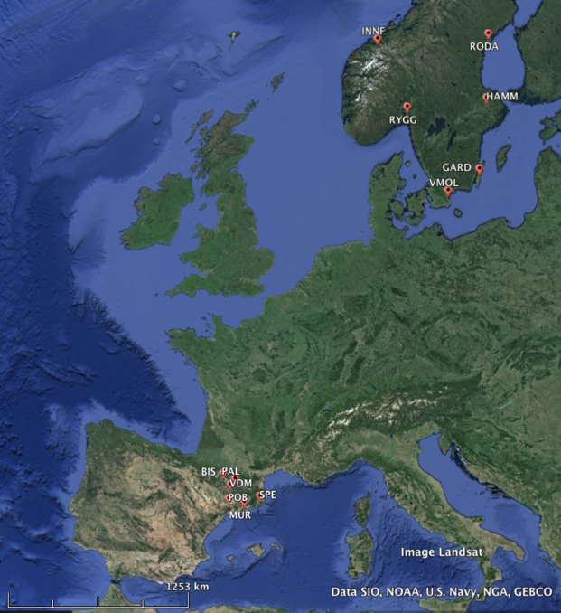
Map of Arabidopsis populations in this experiment. (Map courtesy of Schemske lab at MSU.)

Some Schemske Lab Results on Freezing Tolerance
Region | Population | Latitude | Avg. % Survival
Spain | SPE | 42 | 4%
Scandinavia | INNF | 63 | 96%

The Schemske Lab Story
Currently Doug Schemske and Chris Oakley of Michigan State University and their collaborators are investigating a number of adaptive traits, including freeze tolerance, disease resistance, flowering time, photosynthesis, and circadian rhythm. They are particularly interested in fitness trade-offs; for example, producing “antifreeze” to survive a cold winter might have a negative effect on the number of seeds produced in warmer environments. In the freeze tolerance studies, parent strains were chosen from the northern and southern ends of the plant’s range: Sweden and Italy. Starting from Swedish-Italian hybrids, hundreds of recombinant inbred lines (RILs) were created through careful plant breeding; each line is homozygous for every gene but is different from the other lines. Multiple replicates of both the parent strains and hundreds of RILs were planted at both parent locations and their survival and fruit production (a stand-in for overall fitness) were recorded. (Since A. thaliana seeds are the size of finely ground pepper, it would be challenging to count them accurately.)
Not surprisingly, each parent strain fared best in its native location. The Swedish strain struggled in Italy while the Italian strain struggled during normal Swedish winters but did OK during a mild winter. As expected, the RILs were more variable in their survival and seed production. After the field trials, the genetics of each RIL was examined. Unique genetic markers were used as arbitrary “section breaks”: If the marker came from the Swedish parent, the whole section was assumed to be from the Swedish parent. These markers were used to map quantitative trait loci (QTLs), sections of the chromosome that are responsible for variation in the traits in question, winter survival and fruit production. A total of 15 locations were identified for fitness; one-third of these QTLs showed evidence of trade-offs. For example, a DNA region might be associated with higher survival but also with lower fruit production, depending on the environment the plant was grown in.
The next step in this research is to investigate other traits for potential trade-offs and to determine which genes in particular are in the identified QTL. This knowledge could be applied to food crops, horticulture, or even animal breeding.
Dr. Doug Schemske Dr. Chris Oakley

