

**DRAFT: Bringing back the Trumpeter Swan**

Featured scientist: Wilbur C. “Joe” Johnson

from Kellogg Bird Sanctuary

*Research Background:* The W.K. Kellogg Bird Sanctuary, established in 1927, was originally created to provide protected nesting areas for waterfowl such as ducks, geese, and swans. During that time many waterfowl species were declining due to overhunting and the loss of wetland habitats. One species whose populations had significantly declined was the Trumpeter Swan, the biggest native waterfowl species in North America. Although once a widespread species, by 1935 Trumpeter Swan populations had been reduced to just 69 known individuals in the continental U.S. The swans were no longer found in Michigan.

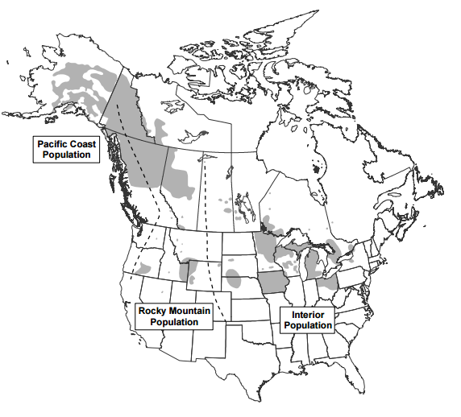The **reintroduction**, or release, of a species into an area where they no longer occur is an important tool in helping them recover. In the 1980s, many biologists came together to create a Trumpeter Swan reintroduction plan. Trumpeter Swans in North America can be broken up into three populations, Pacific Coast, Rocky Mountain, and Interior (see map). Michigan is part of the Mississippi Flyway, which is part of the Interior Population. **Wilbur C. “Joe” Johnson** (photo below), the Kellogg Bird Sanctuary manager and chief biologist, wrote and implemented a plan for Michigan. Joe and a team of biologists flew to Alaska in 1989 to collect swan eggs to be reared at the sanctuary. After two years the swans were released throughout Michigan in prime wetland habitats.

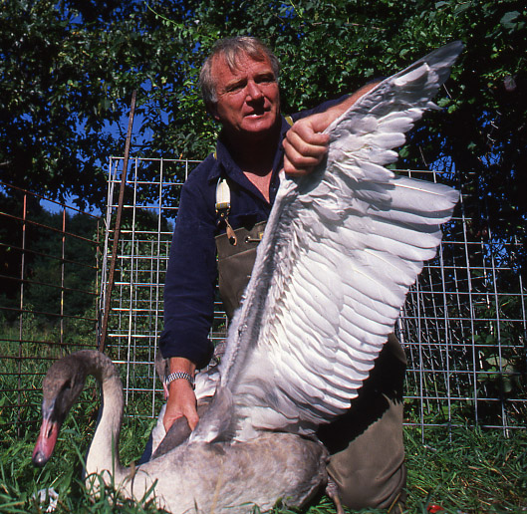

The North American Trumpeter Swan survey has been conducted approximately every 5 years since 1968 as a way to estimate the number of swans throughout their breeding range. The surveys were conducted in late summer when young swans, called cygnets, are incapable of flight but large enough to count. Although the surveys were conducted across the North America, the data below focuses on the Interior Population, which includes swans in the High Plains and Mississippi/Atlantic Flyways.

*Scientific Question*: How has the total number of swans in the Interior Population changed over time?

*Scientific Data:*

**Use the data below to answer the scientific question:**

|  |  |  |  |  |  |  |  |  |  |  |
| --- | --- | --- | --- | --- | --- | --- | --- | --- | --- | --- |
|  |  | Year | | | | | | | | |
| *Interior Population* | | **1968** | **1975** | **1980** | **1985** | **1990** | **1995** | **2000** | **2005** | **2010** |
|  | High Plains | 64 | 116 | 164 | 158 | 185 | 240 | 370 | 471 | 573 |
|  | Mississippi/Atlantic | 0 | 0 | 12 | 51 | 237 | 687 | 2060 | 4176 | 9236 |
|  | **Total** | **64** | **116** | **176** | **209** | **422** | **927** | **2430** | **4647** | **9809** |

What data will you graph to answer the question?

Independent variable: Year (time)

Dependent variable: Number of swans

*Draw your graph below*: Identify any changes, trends, or differences you see in your graph. Draw arrows pointing out what you see, and write one sentence describing what you see next to each arrow.

Note for teachers: Discuss various types of graphs (bar, histogram, line, pie, etc.) with the students and what kind is appropriate for various kinds of data. For this, a line graph is very useful for examining the changes in one variable over time.

There is a positive trend on the graph for both Interior Populations. In 1995 the Mississippi/Atlantic populations begin to grow more rapidly. But a positive trend is consistent across all years.



Note for teachers: Discuss the value and importance of long-term data collection with the students. Could we have learned the same information from a shorter term study? What other adjustments could have been made to this study?

*Interpret the data:*

Make a claim that answers the scientific question.

The overall Interior Population has increased every year since 1968.

What evidence was used to write your claim? Reference specific parts of the table or graph.

The Mississippi/Atlantic group increased the most, going from zero in 1968 to 9,236 swans in 2010. It started to increase the most in 1995 (from 237 to 687). The High Plains population grew much slower and even declined slightly between 1980 and 1985.

Explain your reasoning and why the evidence supports your claim. Connect the data back to what you learned about swan reintroduction efforts in North America and Michigan specifically.

The long term survey gives a clear view of total numbers of Trumpeter Swans before, during, and after the reintroduction efforts. We know swans were raised and released by Joe Johnson in Michigan around 1991, and Michigan is part of the Mississippi Flyway. This could have helped that population grow quicker and it explains the increase in population around 1995.

*Your next steps as a scientist:*

Science is an ongoing process. What other information about the swans do you think should be investigated?

Sometimes only knowing the number of swans isn’t enough information. You may want to know how many of those swans are males and how many are females. You may also want to know the ages of the swans, and whether or not the swans are continuing to reproduce. And you may also want to know more about the habitats they are using, and if they have enough habitats to sustain the populations.

Data source:

The 2010 North American Trumpeter Swan Survey: https://www.fws.gov/migratorybirds/pdf/surveys-and-data/NATrumpeterSwanSurvey_2010.pdf