Lesson Plan: Warming Up with Greenhouse Gases
April 18th, 2017

Scientific Terms in this Lesson:
carbon: an element that can be found in all living things carbon dioxide: a chemical compound composed of two oxygen atoms bonded on either side of a carbon atom (CO₂) usually present as a gas
Plants, animals, microbes, and their processes
algae: plants that mostly grow in water and lacking true roots, stems and leaves.
photosynthesis: the process by which plants use carbon dioxide and energy from the sun to build sugar
respiration: the processes by which plant and animal cells break down sugar, which results in carbon dioxide
decompose: to be broken down physically and chemically by bacterial or fungal action; to rot, often leading to respiration of carbon by microbes.
predator prey: transfer of carbon between plants and animals (microbes can be included), when prey are consumed by a predator.
erosion: the process by which water, ice, wind, or gravity moves weathered rock or soil
sediment: material, such as stones or sand, deposited by water, wind, or glaciers
weathering: the processes by which rocks exposed to the weather change and break down
reservoirs: places where carbon is stored, often referred to as a sink of carbon (think ocean, soil, atmosphere).
flows: the movement between reservoirs, often indicated by errors on diagrams.
atmosphere: the gases surrounding the Earth.
biosphere: the parts of the land, sea, and atmosphere in which life exists.
hydrosphere: all of Earth’s water
lithosphere: rocky outer layer of the Earth.

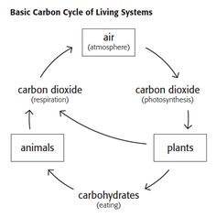
Figure 1. Simple Carbon Transfer System. This is a good place to start for middle school students, but students in high school and advanced middle school classes should work with more complex diagrams that include more reservoirs of carbon and biogeochemical processes (Figure 2). Diagrams can also include human derived changes to carbon and greenhouse gas emission cycling (Figure 3).
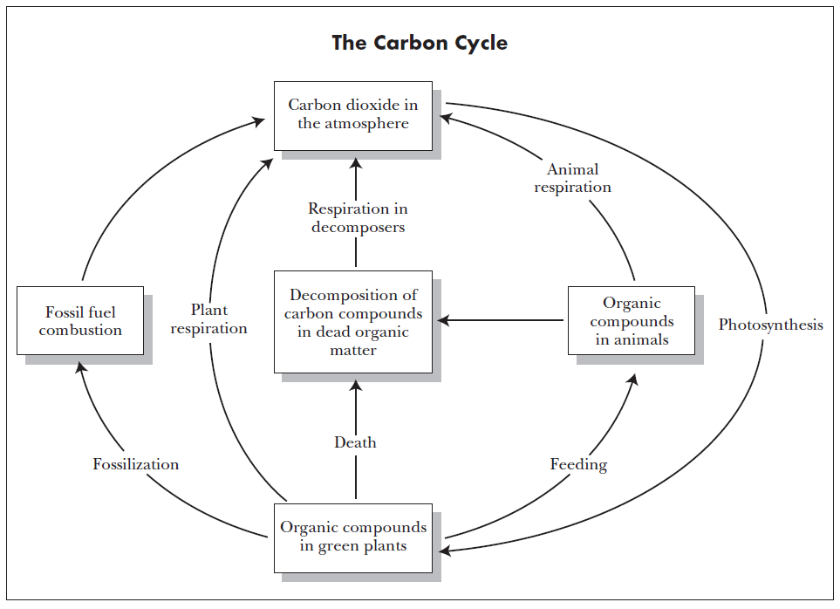

Figure 2. More Complex Diagram of Carbon Transfer. This is a good place to start for high school students. The diagram does not include a lot of human derived changes to the carbon cycle and also does not include specific ecosystems. Show this diagram to students before showing students carbon cycling in specific ecosystems or between specific ecosystems. After students have an understanding of the basic processes of carbon transfer, more complex diagrams can demonstrate more specific interactions between ecosystems and can also include human derived changes to carbon and greenhouse gas emission cycling (Figure 3).

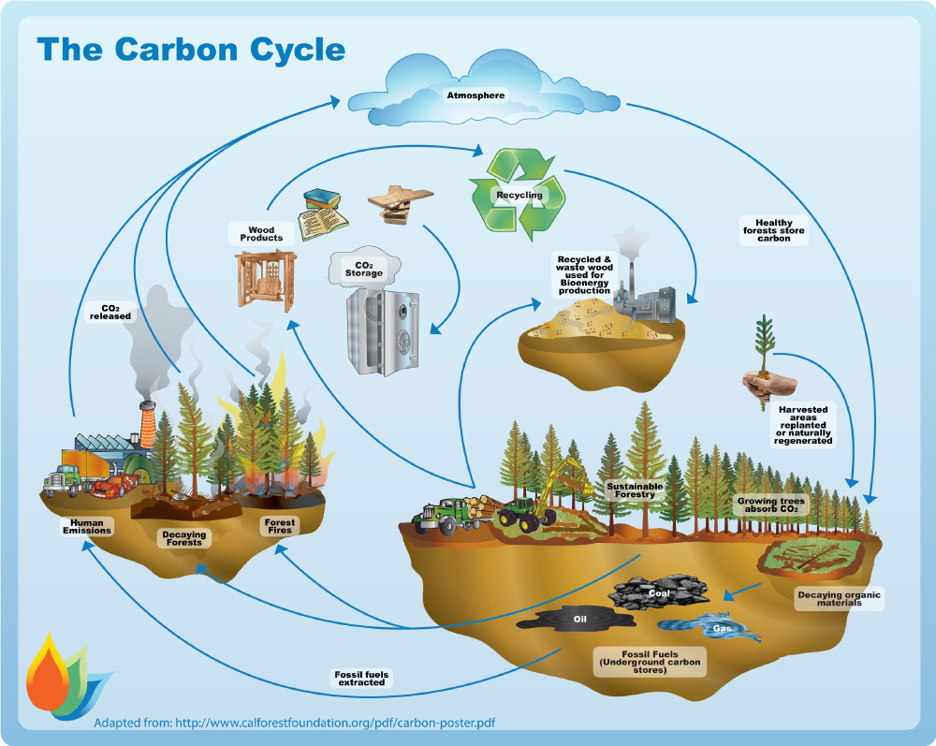
Figure 3. Human influence on carbon cycling. A figure, similar to this one, is good for describing how humans alter the carbon cycle and alter the carbon balance amongst ecosystems and systems.

Activity 1: Carbon Cycle Role-Play
Introduction
Have students recall some of the things in their daily lives that contain carbon. Make a list of these items on the board. Explain to your students that the carbon contained in any one thing doesn’t stay there forever. The carbon atoms move from one thing to another in what is called the carbon cycle. Parts of the carbon cycle happen very quickly, like when plants take in carbon dioxide from the atmosphere for photosynthesis. But, other parts of the carbon cycle happen very slowly.
Tell students that in this activity, they will learn how carbon moves from one place to another, by performing a carbon cycle role-play.

Role-Play
1. Divide students evenly into 7 groups and distribute the appropriate role-play card to each group. Each group will be a team of actors that will play a certain part of the carbon cycle (atmosphere, water, algae, marine snail, sediments & rocks, trees, or caterpillars). The table provided at the end of the lesson plan summarizes all the groups, their options for carbon flow, the explanation for each carbon flow, and their script lines.
2. Distribute 2-4 ping pong balls to each group and explain that these represent carbon atoms. 3. Have students in each group review their role play card to figure out their role in the carbon cycle and decide as a group using their “Options for carbon movement” how they are going to move their carbon. • Explain that they can give their carbon to only one other group, or if they have plenty, they can give the carbon to more than one group. • Explain that carbon exists in all of these things at the same time and only a portion of the carbon in each thing moves. Therefore, when each group moves their carbon, they can’t give away all their carbon: they must keep at least one carbon atom. • As they move their carbon, they must say their script lines to explain the carbon movement that they have chosen.
4. One at a time, ask each group to give their carbon to another group (or groups).
5. Run the role-play a number of times, telling students to make different choices about carbon movement each time, or assign students a number of different rates of marble/carbon transfer.
6. If you have time, consider running the following variations: Have all the groups moving their carbon at the same time: Have one person from each group be the deliverer of carbon and the other group members remain to receive carbon from other groups. Tell students that this is a more chaotic, but more realistic acting out of the carbon cycle, since in the real world carbon moves between all these areas at the same time.
7. Trace the journeys of only few carbon atoms: Use only one carbon atom (ping pong ball) and start it with one group. Each group that gets the atom makes a decision about where it goes next. Assign one student to write the journey on the board or a piece of paper. Do this multiple times so that you can compare the journeys of several individual atoms through the different spheres and see how the carbon cycle does not move in one direction, but moves in lots of different directions at the same time.

Discussion: Human Impacts on the Carbon Cycle
1. Explain to students that they just acted out the carbon cycle without human involvement, but humans greatly influence the carbon cycle with some of their activities.

2. Have students guess what movement corresponds to the following human activities: • Humans extract and burn fossil fuels for energy (carbon moves from the sediments and rocks where fossil fuels are buried into the atmosphere).
- Humans cut and burn trees to use land for farming, ranching, or building (carbon moves from the land plants into the atmosphere).
3. Pull students aside and have them be the humans. Ask them to move the carbon in the appropriate manner for the human activities that you discussed. How did this affect the carbon cycle?
4. Explain that humans have not created more carbon on earth, but that we move carbon from one place to another more quickly than would naturally happen and that this has consequences for the climate of the planet. Some salient examples:
- Burning fossil fuels takes carbon from sediments and rocks where fossil fuels are buried and puts it into the atmosphere because when fossil fuels are burned they release carbon-containing gases.
- Cutting and burning trees takes carbon from the land plants and puts it into the atmosphere because when trees are burned, the carbon that was stored in their structures is released as carbon-containing gases.
5. Ask students if they can think of other human activities that might affect the carbon cycle.

Activity 2: Ice Melting Greenhouse Gas Experiment (Video)
https://www.youtube.com/watch?v=pPRd5GT0v0I

Activity 3: Carbon Footprint (How do you affect the carbon cycle?)
http://www.carbonfootprint.com/calculator.aspx

