Name: ______________________________________ Date: ________________________

How does variation in bacterial populations influence human health?
One morning you wake up with a bad sore throat and you have to go to the doctor to get medicine to make you feel better. Do you think bacteria could be making you feel sick? In our activity beads and pompoms will represent bacteria because remember, even though bacteria are everywhere, they are too tiny to see!

Draw a bead Draw a pompom

List differences between the bead and pompom:

- the
- As
- the
- the
At the doctor you learn that you have a bacterial infection that is making you feel sick. The doctor prescribes you medicine called an antibiotic that will target the harmful bacteria. Circle your favorite color bead. This color represent harmful bacteria, but it will also be the color of the beads on your bracelet.
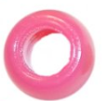
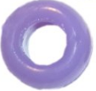
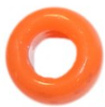

How many ______________ beads are in the population?
^{(color circled above)}

A mutation arises in the population! The mutation changes the appearance of a bead to look like a pompom. How many pompoms of the same color are in the population?

Now use the string that represents the antibiotic medicine to remove as many harmful ___________ bacteria from the population.
^{(color circled above)}

How many beads of the same color are in the population after a dose of antibiotics?

How many pompoms of the same color are in the population after a dose of antibiotics?
Could you remove any of the harmful pompoms from the population using the antibiotics the doctor prescribed?

Do you think you will feel better even though all the harmful pompoms are still alive?

What might a doctor be able to do to help you feel better?

