# **Screen Shot 2015-04-06 at 3.29.47 PM.png**

This work is supported by a grant to The Great Lakes Bioenergy Research Center (DOE Office of Science BER DE-‐FC02-‐07ER64494). Any opinions, findings, conclusions or recommendations expressed in this material are those of the author(s) and do not necessarily reflect the views of the United States Department of Energy

# **Grass-fed Cars**

Dr. Joyce Parker Craig Kohn

Dept. of Earth & Environmental Sciences Dept. of Teacher Education

Center for Integrated Studies in General Science

Michigan State University

Great Lakes Bioenergy Research Center

## **All Activities and more can be found at GLBRC.org/education/classroom-materials**

## **Sustainability – what is it and how do we measure it?**

* Sustainability Lesson
* The Story of Biofuels

## **Bug Biodiversity and Ecosystem Services – 3 Activities**

* Sampling pollinators with bee bowls
* Investigating invertebrates with sweep nets
* Investigating invertebrates with pitfall traps
* Related activity - *Research Story: The Entomology Detective* shows how security surveillance cameras are used by entomologists to figure out what insects inhabit a field.

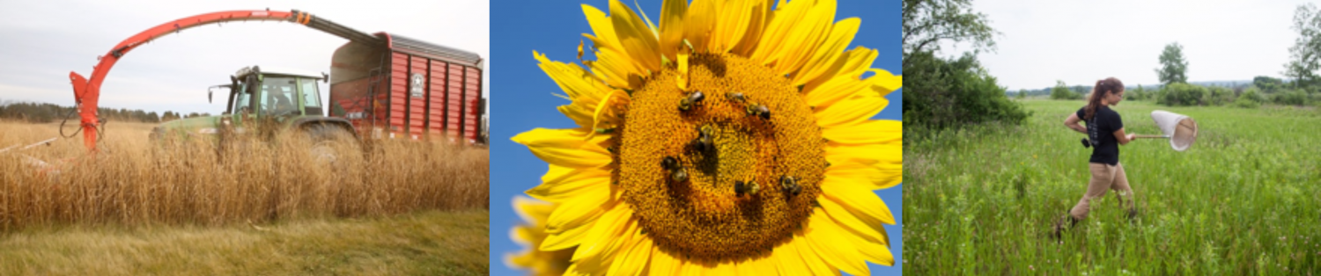

### [**Data Dive: Farming for Beetles, Bees and Biomass**](https://www.glbrc.org/education/classroom-materials/data-dive-farming-beetles-bees-and-biomass)

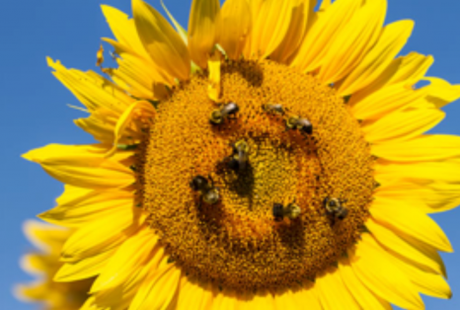

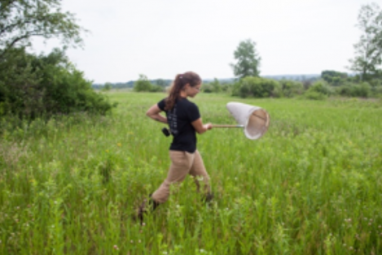

Figure 1: A comparison of the average number of plant and beneficial bug species found in each crop. The error bars represent standard error, a measure of the amount of variation in the species counts between fields.

## **Data Dive: Growing Energy - Analyzing Fuel Crop Yields**

|  |  |  |  |
| --- | --- | --- | --- |
| **Crop** | **Type** | **Average harvested biomass (Mg DM ha-1 yr-1)\*** | **Variation (standard error)\*\*** |
| corn | annual | 14.2 | 0.6 |
| prairie | perennial | 3.3 | 0.2 |
| switchgrass | perennial | 6.5 | 0.3 |
| miscanthus grass | perennial | 14.0 | 0.9 |
| poplar trees | perennial | 8.5 | 1.4 |
| weed field | perennial | 2.7 | 0.2 |

*\*Harvest biomass is measured as the amount of dried biomass harvested from a certain area. In this study the units are “Megagrams of dried biomass per a hectare (Mg DM ha-1).”*

## **Data Dive: Investigating Fuel Carbon Footprints**

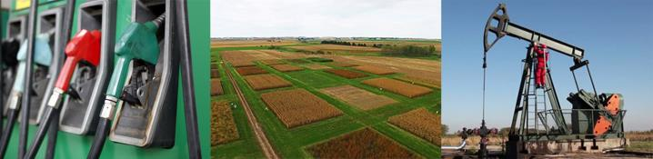

|  |  |
| --- | --- |
| **Fuel** | **Total CO2 equivalents**  **(kg/mi)** |
| Gasoline (100% gasoline) | 0.43345 |
| Cellulosic Ethanol (E100) made from switchgrass | 0.0896 |
| Electricity made from coal | 0.3915 |
| Electricity made from natural gas | 0.1958 |

# **Other GLBRC Activities**

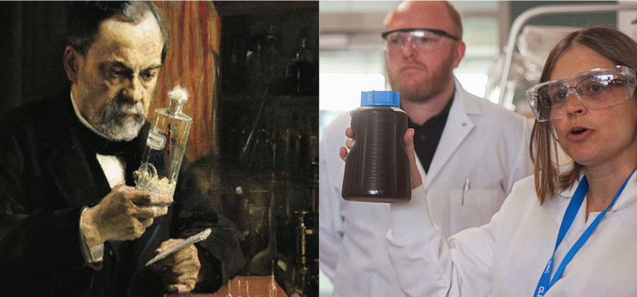

* Making ethanol
* Research stories – GLBRC scientists
  + Farm experiments
  + Entomology detectives
  + The relationship btw science & engineering as it relates to the study of engineering
* Videos of current research

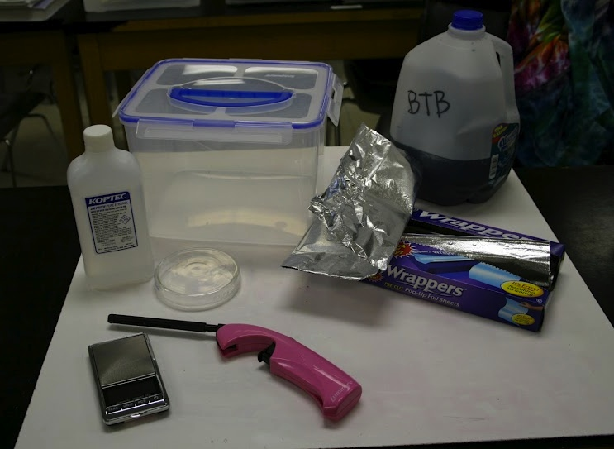

* Biofuels vs Fossil fuels – multiple lessons
  + Combustion
  + Animal and microbial respiration
  + Photosynthesis
  + Fermentation
* Sustainability
* Energy and energy source data; life cycle analyses

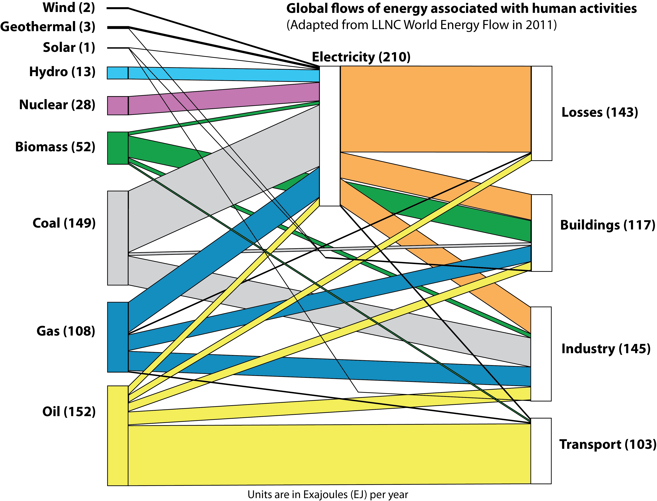

* Carbon Cycle model



## **Alignment with NGSS**

|  |  |  |
| --- | --- | --- |
| **Scientific & Engineering Practices** | **Disciplinary Core Ideas** | **Crosscutting Concepts** |
| Developing & using models  Constructing explanations & designing solutions  Analyzing and interpreting data | LS1: From molecules to organisms: Structures and processes  LS2: Ecosystems: Interactions, energy, & dynamics  ESS2: Earth’s systems  ESS3: Earth and human activity  PS1: Matter and interactions  PS3: Energy | Energy & matter: Flows, cycles, and conservation  Cause & effect: Mechanism & explanation  Scale, proportion, & quantity  Systems & system models |

## **Professional Development Activities**

## [**Bioenergy Institute for Educators (BIE)**](https://www.glbrc.org/education/educational-programs/bioenergy-institute-educators-bie)

|  |
| --- |
| **Timing/Duration:** June 26-30, 2017. Monday-Friday  **Location:** University of Wisconsin-Madison  **Application Deadline:** Accepting applications through May 1, 2017.  **Stipend:** $400  **Who Should Apply:** K-12 educators interested in incorporating bioenergy lessons into their classes. Teams of 2-4 educators (teachers, curriculum coordinators, etc.) are encouraged. |