Field Assignment: How can we make accurate observations of the Sun’s location and movement? Are there any patterns that emerge from our observations?
- Quiet observation
- Sun Scavenger Hunt
  - How long is your shadow? ________ feet ________meters
  - Find something as long as your shadow. What is it?______________________________

  - Find two shadows that touch. Are the objects touching?___________________________

  - Find something that doesn’t cast a shadow. What is it?___________________________
- Driving Questions
  - Create Driving Questions Board
- Sidewalk Shadows
  - Shadow Journal
- Create a sundial
Collect evidence to:
- Create a method to measure the length and direction of shadows over the course of a day.
- Discover the location of the Sun based on the direction of a shadow.
- Use the location of the Sun to describe the direction of the four cardinal directions.
- Observe changes in the size and shape of shadows over time.
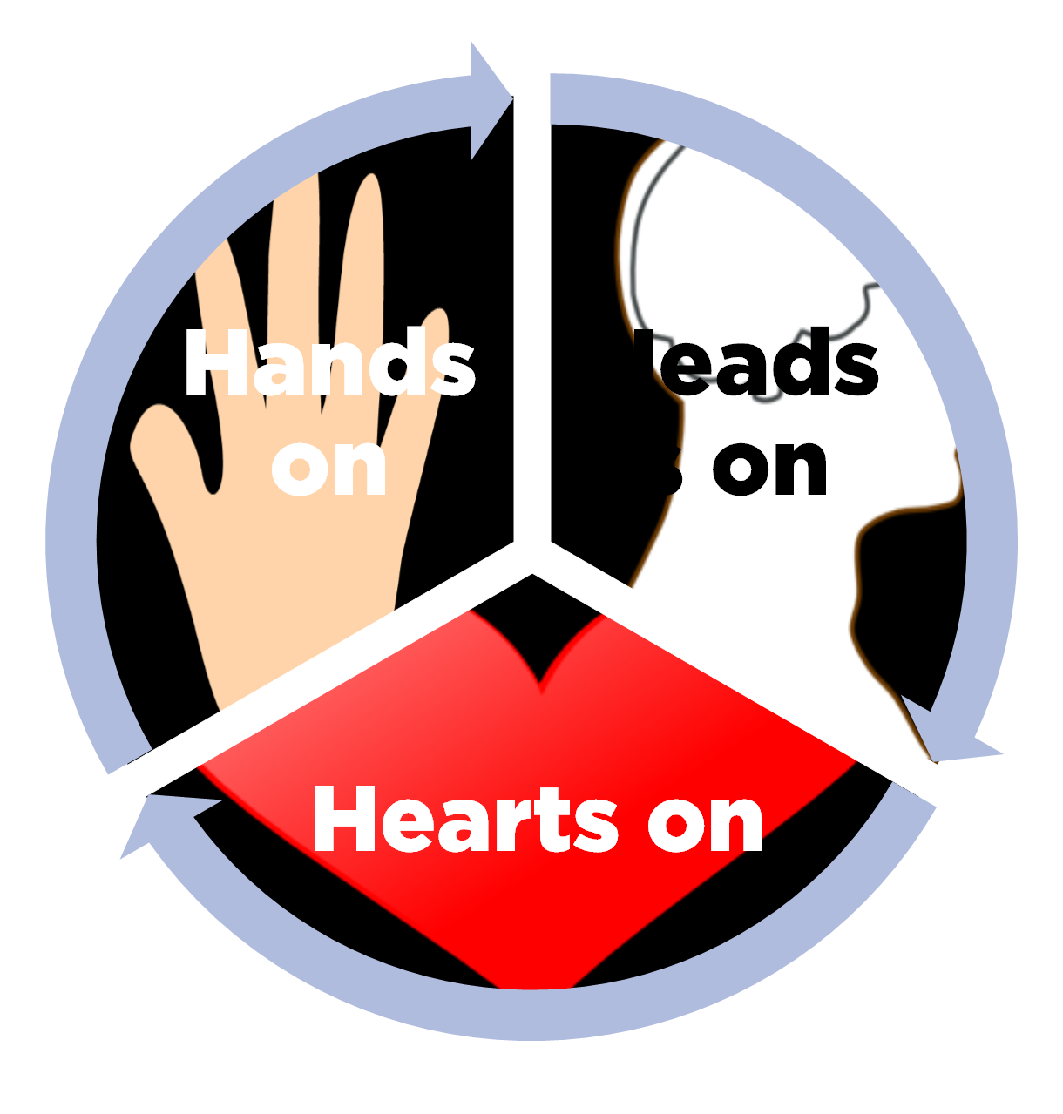
- Predict the size and direction of shadows at various times of day.
- Discover and identify patterns of the Sun throughout a day/year.
- Use the patterns of the Sun to explain/predict other phenomena observed.
Continue to collect and share our data today:
1. Tweet!
- Press the quill icon
- Press the camera icon.
- Take photo of evidence!
- Type question or description
- #KBSK12, @outdoorsteach, @karahaascied, @kelloggbiostn
2. Collect observations (pictures) of our investigation throughout the day.
3. Ask questions about what you observe (type into Twitter or write down)

Debrief:
Hands on, Heads on, Hearts on
- How were your hands, head and heart engaged in this activity?
- For your grade level, how do you envision your students hands, heads and hearts would be engaged?

Next Generation Science Standards (Michigan Science Standards)
1-ESS1-1. Earth’s Place in the Universe: Use observations of the sun, moon, and stars to describe patterns that can be predicted.
Disciplinary Core Ideas:
ESS1.A: The Universe and its Stars
- Patterns of the motion of the sun, moon, and stars in the sky can be observed, described, and predicted. (1-ESS1-1)

ESS1.B: Earth and the Solar System
- Seasonal patterns of sunrise and sunset can be observed, described, and predicted. (1-ESS1-2)
5-ESS1-2. Represent data in graphical displays to reveal patterns of daily changes in length and direction of shadows, day and night, and seasonal appearance of some stars in the night sky.
Disciplinary Core Ideas:

ESS1.A: The Universe and its Stars
- The sun is a star that appears larger and brighter than other stars because it is closer. Stars range greatly in their distance from Earth. (5-ESS1-1)

ESS1.B: Earth and the Solar System
- The orbits of Earth around the sun and of the moon around Earth, together with the rotation of Earth about an axis between its North and South poles, cause observable patterns. These include day and night; daily changes in the length and direction of shadows; and different positions of the sun, moon, and stars at different times of the day, month, and year. (5-ESS1-2)
Common Core connections:
CCSS.MATH.CONTENT.2.MD.A.1. Measure the length of an object by selecting and using appropriate tools such as rulers, yardsticks, meter sticks, and measuring tapes.
CCSS.MATH. CONTENT.3.MD.A.1. Tell and write time to the nearest minute and measure time intervals in minutes. Solve word problems involving addition and subtraction of time intervals in minutes, e.g., by representing the problem on a number line diagram.
CCSS.MATH.CONTENT.4.MD.C.5.A. An angle is measured with reference to a circle with its center at the common endpoint of the rays, by considering the fraction of the circular arc between the points where the two rays intersect the circle. An angle that turns through 1/360 of a circle is called a "one-degree angle," and can be used to measure angles.
CCSS.ELA-LITERACY.SL.4.1. Engage effectively in a range of collaborative discussions (one-on-one, in groups, and teacher-led) with diverse partners on grade 4 topics and texts, building on others' ideas and expressing their own clearly.
Michigan Grade Level Content Expectations:
3-GI.0.1. Use cardinal directions (north, south, east, west) to describe the relative location of significant places in the immediate environment.
Links to helpful resources

Learn more about teacher professional development opportunities at the Kellogg Biological Station: http://www.kbs.msu.edu/outreach/elementary-teacher-program/
Sign up for email updates: http://bit.ly/KBSK12email

Resources for NGSS from CREATE for STEM: http://create4stem.msu.edu/ngss

Next Generation Science Standards, http://www.nextgenscience.org/
Common Core State Standards for Mathematics, http://www.corestandards.org/Math/
Michigan Social Studies Standards, https://www.michigan.gov/documents/mde/SSGLCE_218368_7.pdf
Common Core State Standards for Language Arts, http://www.corestandards.org/ELA-Literacy/

NSTA article: Teaching Through Trade Books: Sunrise, Sunset, and Shadows: http://static.nsta.org/files/sc1504_16.pdf
- Grade 3–5 daylight graph
- Grade 3–5 data sheet
- Grades K–2 student data sheet
- Additional resources
Sun Scavenger Hunt: http://static.nsta.org/connections/elementaryschool/201204Worksheet.pdf
Science and Engineering Practices (Appendices F): http://www.nextgenscience.org/sites/default/files/Appendix%20F%20%20Science%20and%20Engineering%20Practices%20in%20the%20NGSS%20-%20FINAL%20060513.pdf
Online Resources for Sun Shadow Investigations, https://docs.google.com/document/d/1g2x13E0TVSbYJ2E3pkD2uBZ1m0cAYyeIXZwpdXCHXrI/edit?usp=sharing

